Use Cases – Submission of Images and Annotation Files
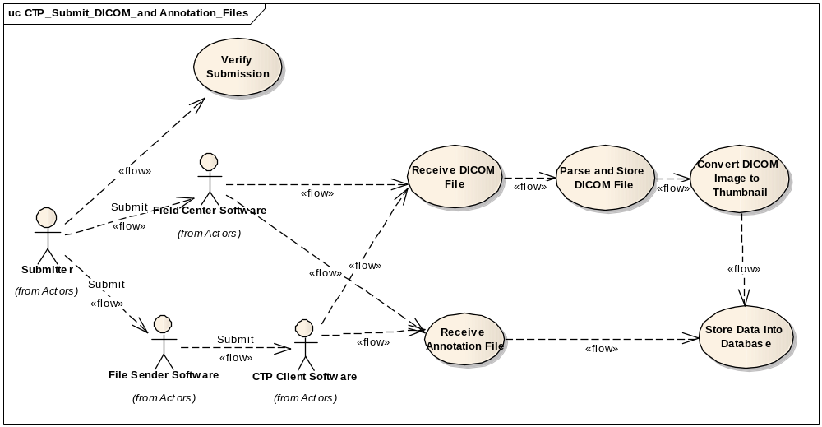

Use Case for NCIA image submission

Brief Description

File Sender and Field Center must be used for existing collection submitted in NCIA, as has been done in previous releases; CTP can be used as a client software to submit new collections to a CTP server component of the NCIA. CTP client needs to be used with File Sender application.

Primary Actor
Submitter

Secondary Actors
Analyst

Preconditions

Precondition One – Anonymizer is configured
Use FieldCenter as a client:
Submitter modifies the dicom-anonymizer.properties for using the TEST collection to your Field Center directory. This properties file can be downloaded from
https://gforge.nci.nih.gov/plugins/scmcvs/cvsweb.php/ncia-mirc/submission/config/test/?cvsroot=ncia
Use CTP/File Sender as a client:
Submitter modifies the da.script under CTP_Installation_direcotry/roots/anonymizer/scripts.
File Sender is not responsible for data anonymization. It just passes the file to CTP client, and CTP client performs data anonymization.

Precondition Two – Reference Image Set must exist
Confirm access to the directories containing the reference image set for image submission testing.
L:\NCICB\NCIA\Reference DataSet\
This directory has images with duplicate sop instance uid problems:
L:\NCICB\NCIA\Reference DataSet\Have duplicate sop instance uid \sd-vc-001\ has two subdirectories ( “p” and “s”) The images under “p” share same sop_instance_uid with images under “s”. If images under “p” submitted successfully, the images under “s” will be quarantined since the software will check for existing sop_instance_uid in NCIA repository. (The ncia.log will display error messages indicate reason these images are quarantined. This also applies to the following folder “L:\NCICB\NCIA\Reference DataSet\Have duplicate sop instance uid\VC-256M”
L:\NCICB\NCIA\Reference DataSet\Regular\ contains only good images that should not fail during transmission.

Basic Flow of Events for Testing by using Field Center
- User uses MIRC Field Center to submit images.
- User verifies state of transmission with the Verify Submission Tool
- On error, analyst checks the logs to validate satisfactory behavior of the system.

Basic Flow of Events for Testing by using CTP and File Sender
- User uses File Sender to submit images.
- User verifies state of transmission with the Verify Submission Tool
- On error, analyst checks the logs to validate satisfactory behavior of the system

Postconditions

Alternate Course 1 – User submits good data

Failures do not occur during transmission and the details of the submission appear in the Verify Submission Tool.

Submit good images first, if these images failed on insert into the database, data in QA database for the TEST collection will need to be cleaned up as these images might have been submitted previously using different idtable. Work with development team (Thai Le) to have this done.

Alternate Course 1 – User submits erroneous data
If the user submits erroneous data, data typical of that bad data in the reference image set, the ncia.log will display error messages indicate reason these images are quarantined.

Specifically, verify in the log files and check the errors that are logged when there is any quarantined file. The log can be viewed using the admin service, under “Tomcat” heading, click on the “Log Viewer” button, this will launch log viewer. There are 3 logs files:
  - ctp.log – contains error or information coming from MIRC software
  - Ncia.log – contains error or information coming from ncia database adapter codes.
Notes: All words highlighted in yellow in the table below will be replaced with actual value at the time the error is generated and entered into the log file.

ERROR MESSAGES | INFORMATION | CORRECTIVE ACTIONS
1. SOP Instance UID (SOPInstanceUID ) has different patient information: patientID in database and thisPatient in the submitted image. | This error occurs when the submitting image has same SOP Instance UID with a different patient ID with an existing image in NCIA database. | User or whoever submitting the image needs to review the submitting image to ensure it belongs to correct patient information:  - Correct patient information in the image if it isn’t correct.  - If the submitting image contains correct patient information then the existing record in NCIA database needs to be investigated and possible removed from the system because an image cannot belong to 2 patients.
2. SOP Instance UID (SOPInstanceUID) has different study information: studyID in database and this StudyID in the submitted image. | This error occurs when the submitting image has same SOP Instance UID with a different study Instance ID with an existing image in NCIA database. | User or whoever submitting the image needs to review the submitting image to ensure it belongs to correct study information:  - Correct study information in the image if it isn’t correct.  - If the submitting image contains correct study information then the existing record in NCIA database needs to be investigated and possible removed from the system because an image cannot belong to 2 studies.
3. SOP Instance UID (SOPInstanceUID) has different series information: seriesID in database and thisSeries in the submitted image. | This error occurs when the submitting image has same SOP Instance UID with a different series Instance ID with an existing image in NCIA database. | User or whoever submitting the image needs to review the submitting image to ensure it belongs to correct series information:  - Correct series information in the image if it isn’t correct.  - If the submitting image contains correct series information then the existing record in NCIA database needs to be investigated and possible removed from the system because an image cannot belong to 2 series.
4. SOP Instance UID (SOPInstanceUID) has different project/collection information: project in database and thisProject in the submitted image. | This error occurs when the submitting image has same SOP Instance UID belongs to different project with an existing image in NCIA database. | User or whoever submitting the image needs to review the submitting image to ensure it belongs to correct project information:  - Correct project information in the image if it isn’t correct.  - If the submitting image contains correct project information then the existing record in NCIA database needs to be investigated and possible removed from the system because an image cannot belong to 2 projects.
5. SOP Instance UID (SOPInstanceUID) has different site information: siteID in database and thisSiteID in the submitted image. | This error occurs when the submitting image has same SOP Instance UID belongs to different site information with an existing image in NCIA database. | User or whoever submitting the image needs to review the submitting image to ensure it belongs to correct site information:  - Correct site information in the image if it isn’t correct.  - If the submitting image contains correct site information then the existing record in NCIA database needs to be investigated and possible removed from the system before resubmitting the image.
6. SOP InstanceUID (SOPInstanceUID) belongs to 2 different series pk id. | This means there are more than one series records with same seriesInstanceUID in NCIA database. | User needs to verify other information in the dicom header besides SOP Instance UID and Series Instance UID such as equipment and compare with existing records in NCIA database to determine which one contains accurate information: Possible actions  - Correct the submitting image if it contains incorrect information and resubmit.  - Removed existing image in NCIA database if it contains inaccurate information and resubmit the image.
7. Project: thisProject Site: thisSiteID Patient ID: thisPatient Study Instance UID: thisStudyID Series Instance UID: thisSeries has ret.size() duplicate records with same SOP Instance UID (SOPInstanceUID) | This error occurs when the submitting image has more than one with same SOP Instance UID in current NCIA Database. (This should not be the case when all duplicate images are cleaned up) | User needs to review the submitting image and possible remove images with same SOP Instance UID in NCIA Database before resubmitting the image.
8. Annotation file submitted: studyInstance UID ( studyInstanceUID ) is different with studyInstance UID in database (study.getStudyInstanceUID()) | This error occurs when the submitting annotation file contains a different study Instance UID than what already exists in NCIA Database. | User has to review the submitted annotation file to ensure that the Study Instance UID is correct.
9. Error in process(DicomObject,String) for file file.getFile().getAbsolutePath() | In addition to the error message, when a dicom file is quarantined, full path of the file name is entered into the log file. This information is to help developer or whoever is trying to resolve quarantine file to easier get the actual filename in the file system that causes the error. | N/A
10. Error in process(XMLObject,String) for file file.getFile().getAbsolutePath() | In addition to error message, when an xml file is quarantined, full path of the file name is entered into the log file. This information is to help developer or whoever is trying to resolve quarantine file to easier get the actual filename in the file system that causes the error. | N/A
11. No seriesInstanceUID or studyInstanceUID found for file file.getFile().getAbsolutePath() | This error occurs when an annotation file (either xml or zip file) does not contain series Instance UID or studyInstanceUID information. | User has to review the submitted annotation file (either xml or zip file) to ensure that series Instance UID and study Instance UID information are in the file.

  - Hibernate.log – contains error or information coming from Hibernate codes

See the screenshots below for details.

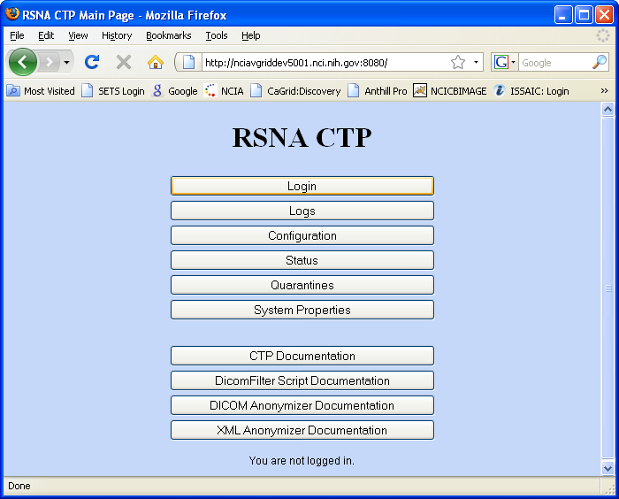
Figure 1: CTP login Page
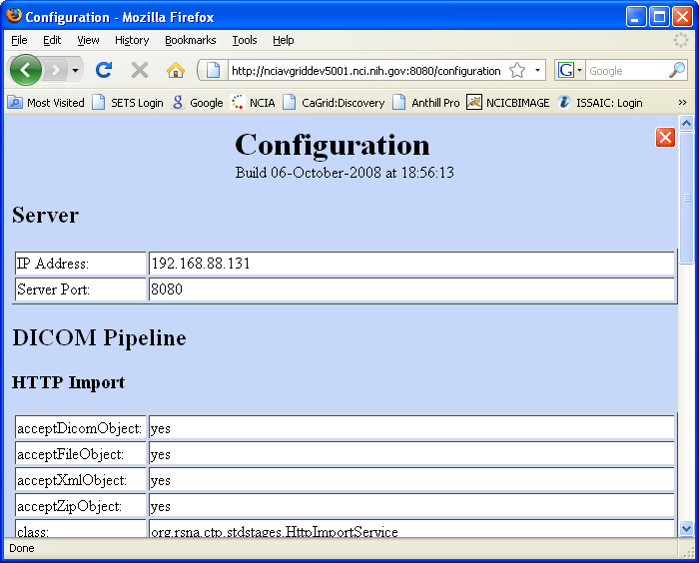
Figure 2: CTP System Configuration Page
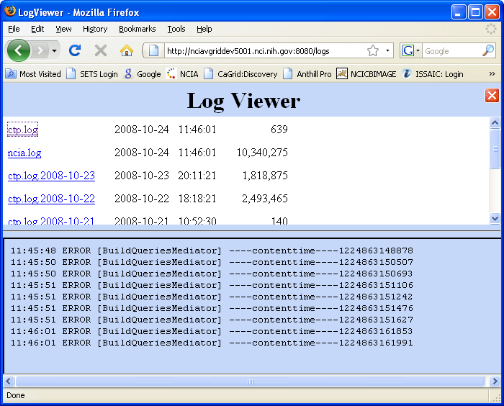
Figure 3: CTP Log Viewer Page
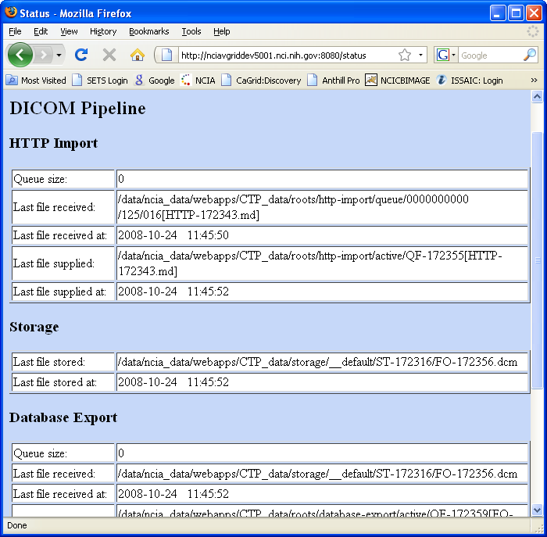
Figure 4: CTP Status Page

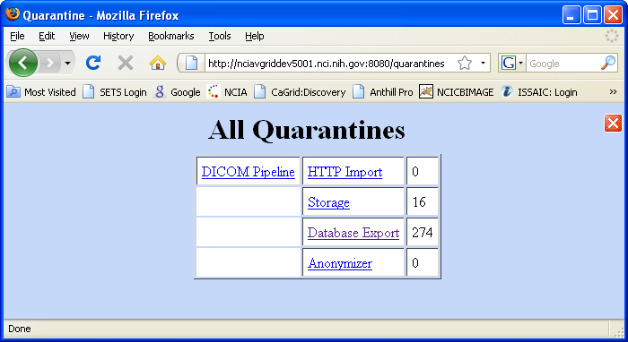
Figure 5: CTP Quarantine Page

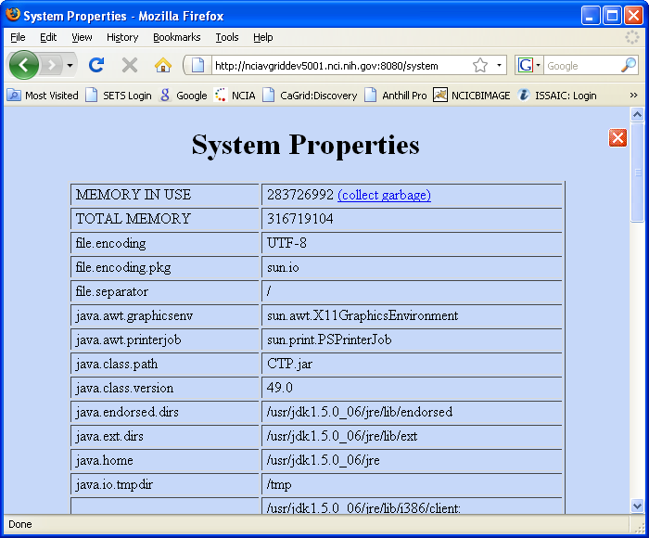
Figure 6: CTP System Properties Page

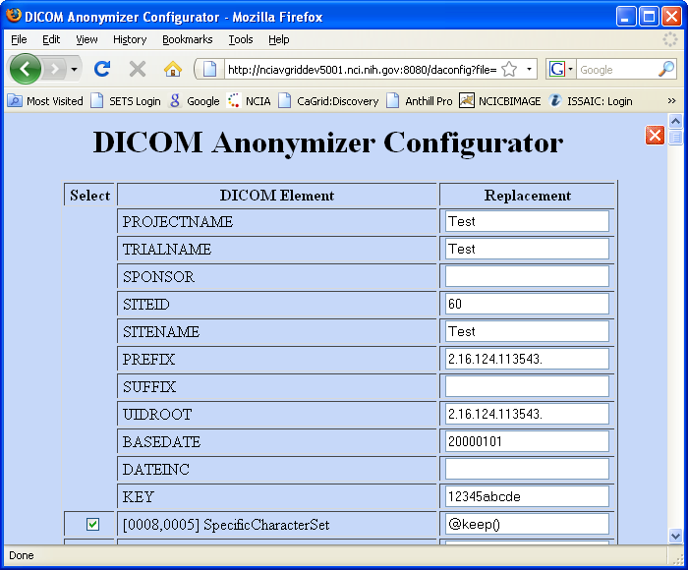
Figure 7: CTP Anonymizer Configuration Page

Postcondition
The markup performed by the user is saved into the database.

Special Requirements
NA

Receive DICOM File

Brief Description
This use case describes how DICOM images are submitted to NCIA, stored in the file system and parsed into the database. DICOM (Digital Communications in Medicine) is a standard for digital medical images. MIRC Server Software is used to manage image submission. Submitters use the MIRC client software (Field Center and File Sender) to submit files to MIRC Server Software.

Primary Actor
CTP Server Software

Secondary Actors

- Submitter
- Field Center Software
- File Sender / CTP Client Software

Preconditions

Precondition 1 –Image File Submitted
The DICOM has been submitted in any of the following ways by the Submitter:
- Using File Sender Software and CTP Client Software to submit via HTTP/HTTPS
- Using Field Center to submit directly to CTP server via DICOM Storage Service protocol (within NIH firewall)
- Submit directly from image software that implements DICOM Storage Service to CTP Server Software (within NIH firewall)

Precondition 2 – De-identification
If required, private patient information has been encrypted from the DICOM file. For submissions via HTTP, this can be done by configuring Field Center Software or CTP client.

Basic Flow of Events
- CTP Server Software receives the DICOM file.
- The DICOM file is parsed and data about the image is stored in the database (see “Parse and Store DICOM File” use case).
- A thumbnail image of the DICOM file is created (see “Convert DICOM Image to thumbnail” use case).

Alternate Courses

Alternate Course 1 – File is Quarantined
An error occurred during the processing of the file. The CTP Server Software places the file in a quarantine directory. Submitter can access CTP GUI to view all quarantined files or he/she can contact NCICB Application Support for assistance.
Quarantined files can be categorized into four types in CTP.
- Http Import
- Dicom Import
- Anonymizer
- Database Export

Postconditions

Postcondition 1 – DICOM File Stored in File System and Referenced in Database
The DICOM file and its thumbnail are stored in the file system. Data from the relevant DICOM header fields is stored in the database along with the path to the DICOM file.

Special Requirements
Not Applicable

Receive Annotation File

Brief Description
This use case describes how annotation files are submitted to NCIA, stored in the file system and parsed into the database. CTP Server Software is used to manage annotation file submission. Annotation files are any non-image file that is submitted to CTP. Annotation files must either be XML files containing the series instance UID or ZIP file that have an XML manifest that contains the series instance UID. Submitters use the CTP client software (Field Center and File Sender / CTP Client) to submit files to CTP Server Software.

Primary Actor
CTP Server Software

Secondary Actors
- Submitter
- Field Center Software
- File Sender / CTP Client Software

Preconditions

Precondition 1 –Annotation File Submitted
The annotation file has been submitted by the Submitter using Field Center Software or File Sender / CTP Client software.

Precondition 2 – Deidentification
If required, private patient information has been removed from the annotation file. This can be done using Field Center Software or File Sender / CTP Client. For submissions via HTTP/HTTPS, this can be done by configuring Field Center Software or File Sender / CTP Client.

Basic Flow of Events
- CTP Server Software receives the annotation file in XML or ZIP format.
- The Study Instance Unique Identifier (UID) is extracted from the annotation file. For XML files, it is extracted from the annotation file itself. For ZIP files, it is extracted from manifest.xml within the zip file.
- The Series Instance UID is extracted from the annotation file.
- The annotation file is stored in the file system in the same directory that series are stored in for the study with the Study Instance UID extracted from the file. The name of the file is the same as its Series Instance UID.
- A record is created in the database that stores the path to the annotation file and the Series Instance UID. No other data is stored in the database from the annotation file.

Alternate Courses

Alternate Course 1 – Series Does Not Exist
A series with the Series Instance UID does not exist yet. When the series is created, the annotation flag will be set to true and the annotation records will be updated to point to the series.

Alternate Course 2 – File is Quarantined
An error occurred during the processing of the file. The CTP Server Software places the file in a quarantine directory. Submitter can contact NCICB Application Support for assistance.

Postconditions

Postcondition 1 – Annotation File Stored in File System and Referenced in Database
The Annotation file is stored in the file system. The corresponding series has been updated in the database.

Special Requirements
Not Applicable

Parse and Store DICOM File

Brief Description
DICOM header data needs to be stored in the database to facilitate searching. CTP Software’s Database Export Module parses out the fields and stores them in the database.

Primary Actor
CTP Server Software

Secondary Actors
Submitter
Applications Support

Preconditions

Precondition 1 - DICOM File Received by CTP
DICOM image has been received by the CTP Server Software.

Basic Flow of Events
- The CTP Server Software’s DICOM parser reads the image file.
- The DICOM parser parses the header information based on a properties file
- Data provenance information is extracted from the DICOM header.
- The parser stores selected DICOM header information and the data provenance information in the database. If the subject, study, or series for this image does not exist yet, it will be created.
- If this image is the first image for its series, check to determine if there are any annotation files for the series. If there are, set the annotation flag for the series to true and set the annotation records to point to the series.
- The location of the image is stored in the database.
- QA Status for the image is set to Not Yet Reviewed in the database.
- The DICOM file is anonymized to remove data provenance information.

Alternate Courses

Alternate Course 1 – Trial Data Provenance Fields Are Not Included in the DICOM Header
CTP Server Software determines whether the image has already been submitted. This will be true when there is an image in the database that matches the following fields in the header:
- Image SOP Instance UID
- Series Instance UID
- Study Instance UID
- Patient ID
If the image has been previously submitted, the existing image data is updated with the data from the newly submitted image.

If the image has not been previously submitted, it will be placed in quarantine because the trial data provenance information was not provided.

Alternate Course 2 – File is Quarantined
An error occurred during the processing of the file. The CTP Server Software places the file in a quarantine directory. Submitter can access CTP console to view quarantined data, or submitter can contact NCICB Application Support for assistance.

Postconditions

Postcondition 1 – DICOM Image Stored in File System and Referenced in Database
Image is stored in file system. Data for the image is stored in database.

Special Requirements
Not Applicable

Convert DICOM Image to Thumbnail

Brief Description
A thumbnail must be created for every image that is stored in NCIA. The thumbnail is used for display purposes to allow users to easily look at a large set of images and choose the images that they want.

Primary Actor
CTP Server Software

Secondary Actors
- Submitter
- Applications Support

Preconditions

Precondition 1 - DICOM File Received by MIRC Server Software
A DICOM image has been received by the CTP Server Software.

Basic Flow of Events
- CTP Server Software extracts the image from the DICOM file.
- CTP Server Software creates a thumbnail from the image.
- The thumbnail is stored on the file system in the same directory as the DICOM file. The thumbnail file has the same name as the DICOM file, but has a different extension.

Alternate Courses

Alternate Course 1 – File is Quarantined
The conversion process fails and the images cannot be converted to thumbnail. The image file is place in a quarantine directory. Submitter can contact Applications Support for details.

Postconditions

Postcondition 1 – Thumbnail Created
Thumbnail image file is stored in file system.

Special Requirements
Not Applicable

Store DICOM Header information/Annotation information into Database

Brief Description
After converting DICOM file into a thumbnail file, Data submission software needs to store specific DICOM header information / Annotation Information into database through DB adapter. These information can be retrieved from NCIA application for display purpose.

Primary Actor
CTP Server Software

Secondary Actors
- NCIA software
- Application Support

Preconditions

Precondition 1 - Files Submitted
Submitter has submitted DICOM files or Annotation files

Precondition 2 – Anonymizer
All submitted files must be anonymized.

Basic Flow of Events
- Extract specific in formation of DICOM / Annotation file
- Validate these information
- Insert extracted data into database.

Alternate Courses

Alternate Course 1 – File is Quarantined
An error occurred during data validation or data insertion. The CTP Server Software places the file in a quarantine directory. Submitter can access CTP console to view quarantined data, or submitter can contact NCICB Application Support for assistance.

Postconditions

Postcondition 1 – Data in database
DICOM header information or annotation information are in database.

Special Requirements
Not Applicable

Verify that Submitted Files Were Received

Brief Description
After submitting images and/or annotation files to NCIA, Submitters need a way to determine if the images were received successfully. This use case describes a process where users can run a report to show statistics about files submitted from their site.

Primary Actor
Submitter

Secondary Actors
- NCIA Software
- Applications Support

Preconditions

Precondition 1 - Files Submitted
Submitter has submitted images or annotation files

Precondition 2 – Submitter Authorized to Verify Submission
Submitter has been granted the VIEW_SUBMISSION_REPORT role for at least one protection element representing a site.

Basic Flow of Events
- Submitter navigates to the “Verify Submission” page.
- Submitter is presented with the following search fields:
- Date Range
- Submitter chooses a date range to search on and presses the Search button.
- Submitter is presented with the following search results grouped by site for each site for which they have the VIEW_SUBMISSION_REPORT role:
- Number of the following that were submitted successfully for the site on each day in the date range:
- Patients
- Studies
- Series
- Images (showing number of images with a QA status of Visible in parentheses)
- Annotation Files
      - Number of files that were quarantined that could be identified as coming from the site on each day in the date range. The NCIA Software will attempt to identify the site that each file belongs to.
      - For DICOM files, it will attempt to look at the header fields.
      - For XML files, it will attempt to parse out the series instance UID (“Receive Annotation File” use case). Based on the series instance UID, it will attempt determine the site that the file is associated with.
      - For ZIP files, it will attempt to parse out the series instance UID from the manifest XML file. Based on the series instance UID, it will attempt determine the site that the file is associated with.
- Submitter is also presented with the number of files that have been quarantined but for which the site cannot be determined (for example, invalid DICOM header, no manifest in zip file, etc).

Alternate Courses

Alternate Course 1 – Verify Submission Page Not Available Because of Security

Submitter has not been granted the VIEW_SUBMISSION_REPORT role for any protection elements representing a site. The link to the Verify Submission page does not appear.

Alternate Course 2 – Invalid Date Range

- Submitter entered a date range where the From date is greater than the To date. Instead of performing the search, display the following message: “To date must be after the From date”.
- Submitter entered a To date without a From date. Instead of performing the search, display the following message: “If a To date is included, a From date must be included.”
- Submitter entered an invalid From Date or To Date. Instead of performing the search, display the following message: “{0} is an invalid date”, where {0} indicates the field name.
- Submitter entered a From date or a To date that is later than today’s date. “{0} must be not be in the future”, where {0} indicates the field name.

Postconditions

Postcondition 1 – Verify Submission Report Displayed
Submitter analyzes results to determine whether all the files they submitted were received successfully. If there are any quarantined files or files that were not received, submitter calls Applications Support to resolve the issue.

Special Requirements
Not Applicable

